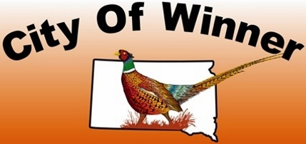

CITY OF WINNER ON-PREMISE FULL-SERVICE RESTAURANT LIQUOR LICENSE APPLICATION INFORMATION
Explanations
- An applicant wishing to sell on-sale liquor in the bar and dining room of a restaurant.
- “Bar” any permanently installed counter withing the restaurant area from which alcoholic beverages are regularly served to customers by a person who is tending bar or drawing or mixing alcoholic beverages (SDCL 35-4-110(1)).
- “Full-Service restaurant” any restaurant at which a waiter or waitress delivers food and drink offered from a printed food menu to patrons at tables, booths, or the bar. Any restaurant that only serves fry orders or foodstuffs such as sandwiches, hamburgers, or salads is not a full-service restaurant (SDCL 35-4-110(2)).
- “Restaurant” any area in a building maintained, advertised, and held out to the public as a place where individually priced meals are prepared and served primarily for consumption in such area and where at least sixty (60%) percent of the gross revenue of the restaurant is derived from the sale of food and nonalcoholic beverages. The restaurant shall have a dining room or rooms, a kitchen, and the number and kinds of employees necessary for he preparing, cooking, and serving of meals (SDCL 35-4-110(3)).
Hours
- 7 a.m. to 2 a.m. daily
Term
- The Retail Liquor Restaurant License runs from January 1 through December 31 of any given year and renewed each Fall for renewal fee of $1000.
Regulations
- At least 60% of the gross revenue of the restaurant must come from the sale of food and nonalcoholic beverages. An annual report shall be submitted to the Finance Officer with documentation to support food and nonalcoholic beverage gross revenue and total gross revenue.
- On-premise consumption required. Alcoholic beverages for on-premise consumption may only be sold in the bar and dining room area of the restaurant.
- Must advertise as primarily a food eating establishment.
- No smoking allowed on the license’s premises.
- Employees 18 and over may sell or serve alcoholic beverages as long as there is an employee on the premise who is at least 21 years of age. However, the minimum age to mix and pour alcoholic beverages is 21.

